WHO-GMP Certified Remove WHO-GMP wherever written in the complete website · ISO 9001:2015 · Nationwide Distribution
+91 98166 67007|support@samaypharmaindia.com
 Increase the size of the Logo
HomeAbout
Available
CertificationsContact
Get a Quote
India's Most Trusted Pharmaceutical Company
AdvancingHealth
Through Manufacturing Excellence
Manufacturing certified, quality-assured medicines for hospitals, pharmacies, and healthcare partners across India. Replace it with a more suitable phrase for a manufacturer
Browse Products
Request a Quote
5,000+ 500+
Products Available
1,200+
Healthcare Partners Parties/Clients
25+ Remove experience related section from everywhere
Years Experience
98%
Client Satisfaction
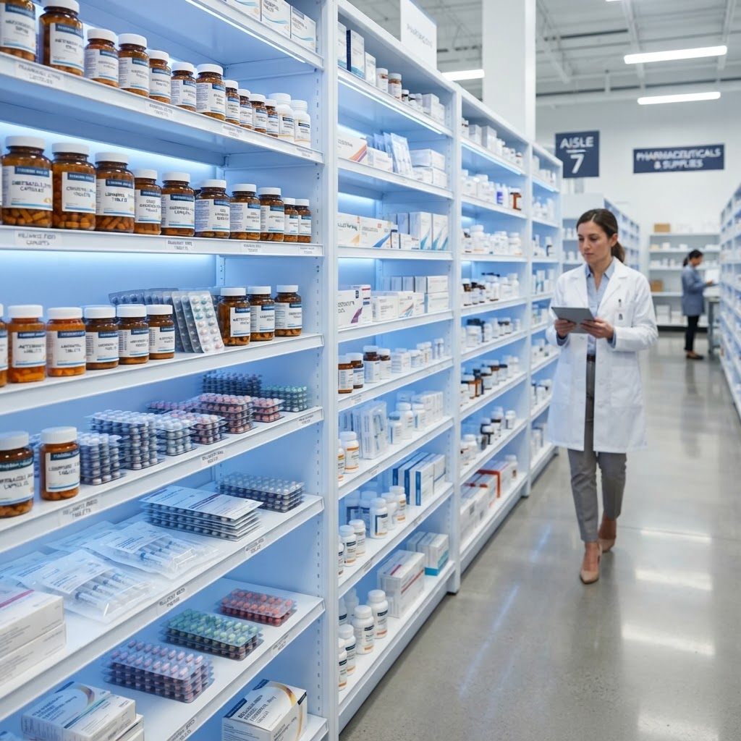 Change Photographs
Delivery Coverage
Pan-India28 States
Metro Cities24-hr Delivery Remove
Emergency24/7 Support
25+
Years of
Excellence
Trusted by Leading Pharmaceutical Partners
Sun Pharma
Cipla
Dr. Reddys
Lupin
Abbott India
Pfizer
Novartis
GSK
Zydus
Torrent Pharma
Sun Pharma
Cipla
Dr. Reddys
Lupin
Abbott India
Pfizer
Novartis
GSK
Zydus
Torrent Pharma
Sun Pharma
Cipla
Dr. Reddys
Lupin
Abbott India
Pfizer
Novartis
GSK
Zydus
Torrent Pharma
Sun Pharma
Cipla
Dr. Reddys
Lupin
Abbott India
Pfizer
Novartis
GSK
Zydus
Torrent Pharma
Sun Pharma
Cipla
Dr. Reddys
Lupin
Abbott India
Pfizer
Novartis
GSK
Zydus
Torrent Pharma
Sun Pharma
Cipla
Dr. Reddys
Lupin
Abbott India
Pfizer
Novartis
GSK
Zydus
Torrent Pharma Replace all these brand partner with Samay Pharma Brand Products
About Samay Pharma
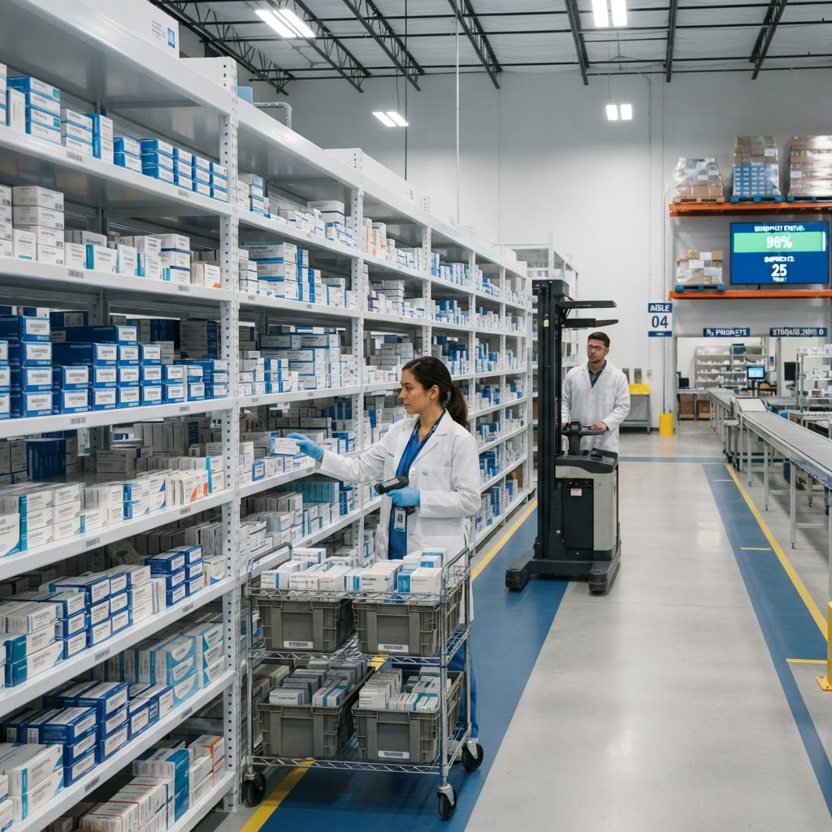
Replace photograph with mfg
Kala Amb, H.P.
TAB
Tablets
CAP
Capsules
LIQ Oral Liquid
Liquids
OIN External Preparations
Ointments
Our Story
BuildingaHealthierLifeThroughQuality Medicines
Based in Kala Amb, Himachal Pradesh, Samay Pharma India manufactures quality medicines — tablets, capsules, liquids, and ointments — to international pharmacopoeia standards, at prices meant to stay within reach.
- GMP-GLP compliant plant with modern labs, chemical plants, and large-scale lines
- Full oral and topical range: tablets, capsules, liquids, and ointments
- In-house R&D for formulation work, including prolonged-release products
- Third-party manufacturing for small and large pharmaceutical companies
- Add a line for PCD
Discover More
Our Lab Expertise Our Product Range
ComprehensivePharmaceutical Catalog
Capsules, tablets, oral liquids, and ointments — our core pharmaceutical dosage forms for modern healthcare.

01
Capsules
Hard gelatin, softgel & HPMC encapsulated formulations for precise dosing.
40 FormulationsGelatin & HPMC
Explore Range →

02
Tablets
Film-coated, enteric-coated, chewable & sustained release tablets.
304 FormulationsCoated & Uncoated
Explore Range →

03
Oral Liquids
Pediatric syrups, oral liquid suspensions, medicinal drops & solutions.
67 FormulationsSyrups & Suspensions
Explore Range →

04
Ointments
Dermatological creams, medicated gels & topical pharmaceutical ointments.
46 FormulationsCreams & Gels
Explore Range →

Recent Products
Medical Products
View All
AllCapsulesTabletsOral LiquidsOintments

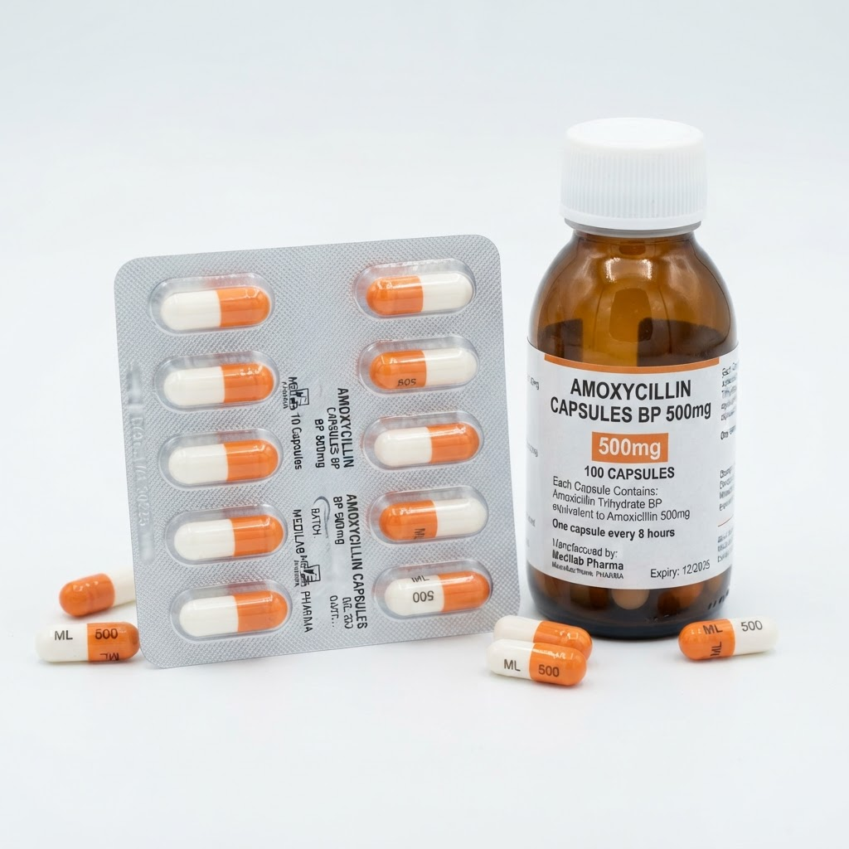
Quick View
Capsules
GSK Pharma
Amoxicillin 500mg Capsules
Broad-spectrum penicillin antibiotic for bacterial infections
Request Quote

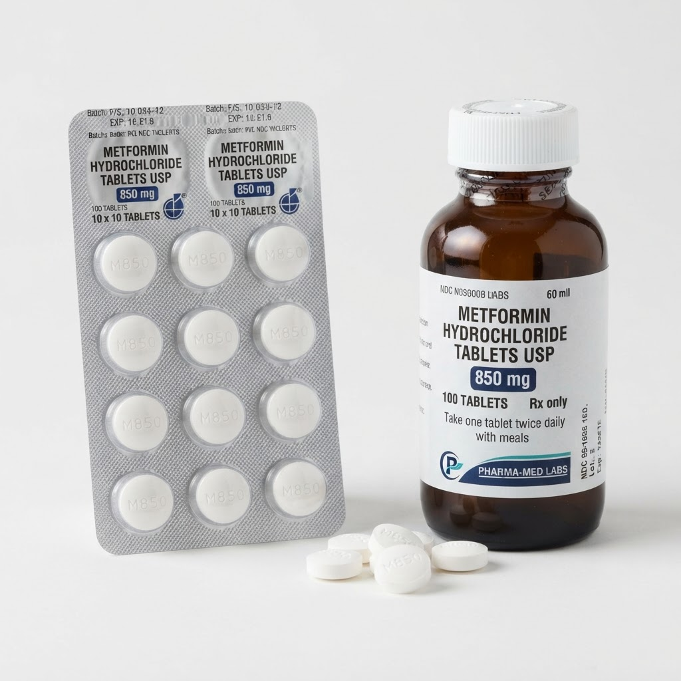
Quick View
Tablets
Sun Pharma
Metformin 850mg Tablets
First-line oral antidiabetic agent for Type 2 Diabetes Mellitus
Request Quote

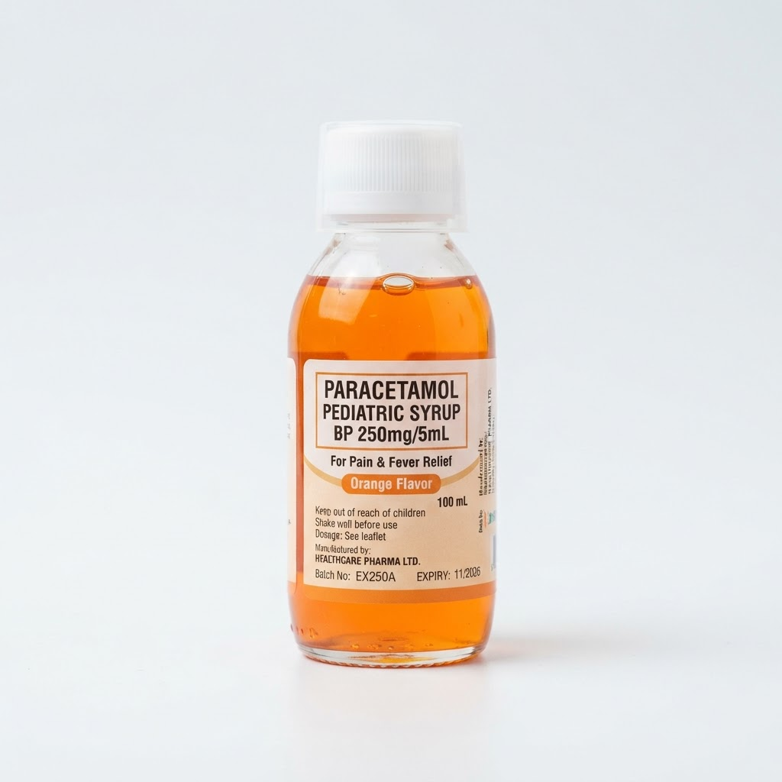
Quick View
Oral Liquids
Abbott India
Paracetamol 250mg Syrup
Analgesic and antipyretic syrup formulation for pediatric use
Request Quote

Quick View
Oral Liquids
Samay Pharma
Cough Syrup 100ml
Oral liquid formulation for relief of dry and productive cough
Request Quote

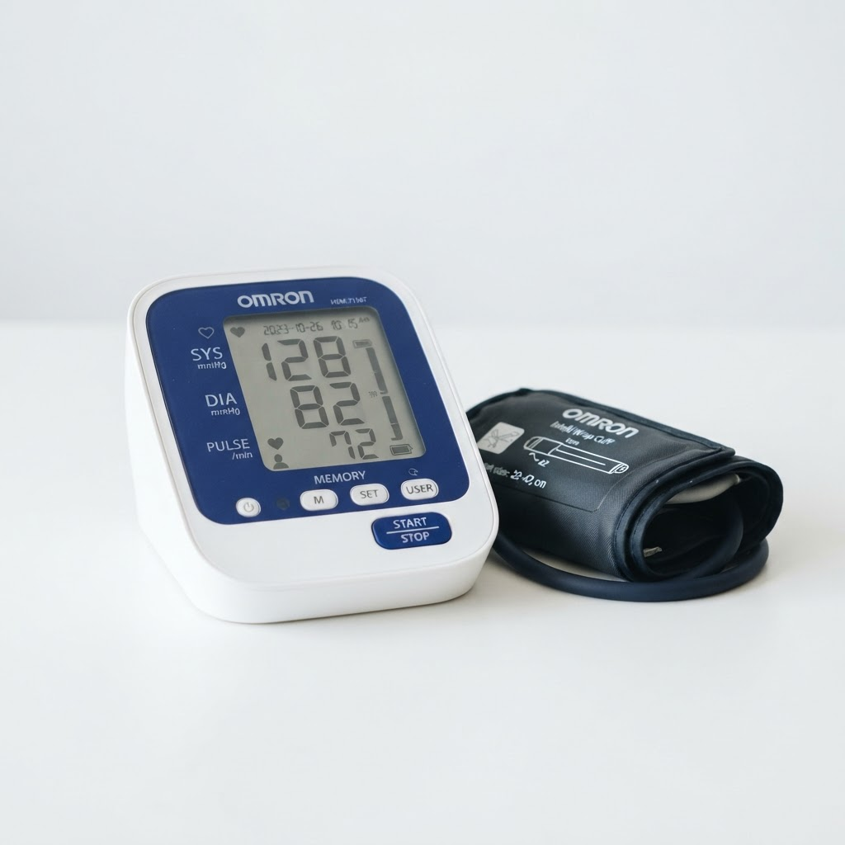
Quick View
Ointments
Samay Pharma
Diclofenac Gel 30g
Topical NSAID gel for musculoskeletal pain and inflammation
Request Quote

Why Choose Us
TheSamayPharma Promise
We believe access to safe, effective, and affordable healthcare is a right — and we manufacture to that standard.
GMP-GLP Certified
Manufacturing aligned to GMP-GLP, pharmacopoeia standards, and statutory requirements — so composition, purity, and safety stay consistent.
Third-Party Manufacturing
Contract manufacturing for small and large pharma companies that need a reliable partner for quality products at scale.
Certified Quality
GMP, ISO 9001:2015, and FSSAI credentials behind how we manufacture, test, and release every batch. Remove FSSAI
Dedicated Team
A focused team working to keep quality high and medicines effective — from the plant floor to the partners we serve.
Two-Location Setup one location setup only in himachal
Corporate office in Delhi and a manufacturing unit in Kala Amb, Himachal Pradesh — with shear, fluid-bed, and film-coating capability.
Affordable Medicines
Quality formulations at reasonable prices, from everyday remedies to complex prescription medicines.
Quality & Certifications
Internationally Recognized Standards
Every product we manufacture is held to international quality norms — effective, pure, and composed to the required standard.
GMP
GLP compliant
ISO
9001:2015
FSSAI
Certified
2
Facilities
View all compliance documents
GMP Certification
Good Manufacturing Practice
Manufacturing aligned to GMP so every batch meets required quality and safety standards
Active
GLP Compliance
Good Laboratory Practice
GMP-GLP compliant operations across formulation, testing, and quality control
Active
ISO 9001:2015
Quality Management
International quality management system covering how we manufacture and control our products
Active
FSSAI Certification
Food Safety Standards
Certified against FSSAI requirements for applicable product categories
Active
Pharmacopoeia Standards
Statutory Compliance
Products formulated to meet relevant pharmacopoeia standards and statutory requirements
Active
Our Process
Howdoesit Work?
From inquiry to doorstep delivery — simple steps that power reliable pharmaceutical manufacturing and supply.
Send Inquiry
Submit your product requirements via our online form, email, or phone. Our team responds within 2 hours.
1
Consultation
Our pharmaceutical experts review your needs and provide tailored product recommendations with pricing.
2
Order Processing
Once confirmed, your order is verified, documents prepared, and production is scheduled at our manufacturing unit.
3
Dispatch
Products packed in cold-chain compliant packaging and dispatched via our trusted logistics partners.
4
Valuable Feedback
OurHappy
Customers Review
1,200+ Partners
98% Satisfaction

Dr. Rajesh Sharma
Procurement Head at Apollo Hospitals
Samay Pharma has been our primary manufacturing partner for 8 years. Their product quality, documentation, and delivery reliability is unmatched in the industry.

Priya Mehta
Supply Chain Director at MedLife Healthcare
The breadth of their catalog combined with WHO-GMP compliance gives us confidence in every order. Exceptional customer service and transparent pricing.
Mohammed Iqbal
General Manager at City Hospital Network
We've streamlined our pharmaceutical procurement by 40% since partnering with Samay Pharma. Their ordering process is a game-changer.
Trends and Updates
LatestResearchandLaboratory Insights
Make more realistic and relatable feedback for a manufacturer image
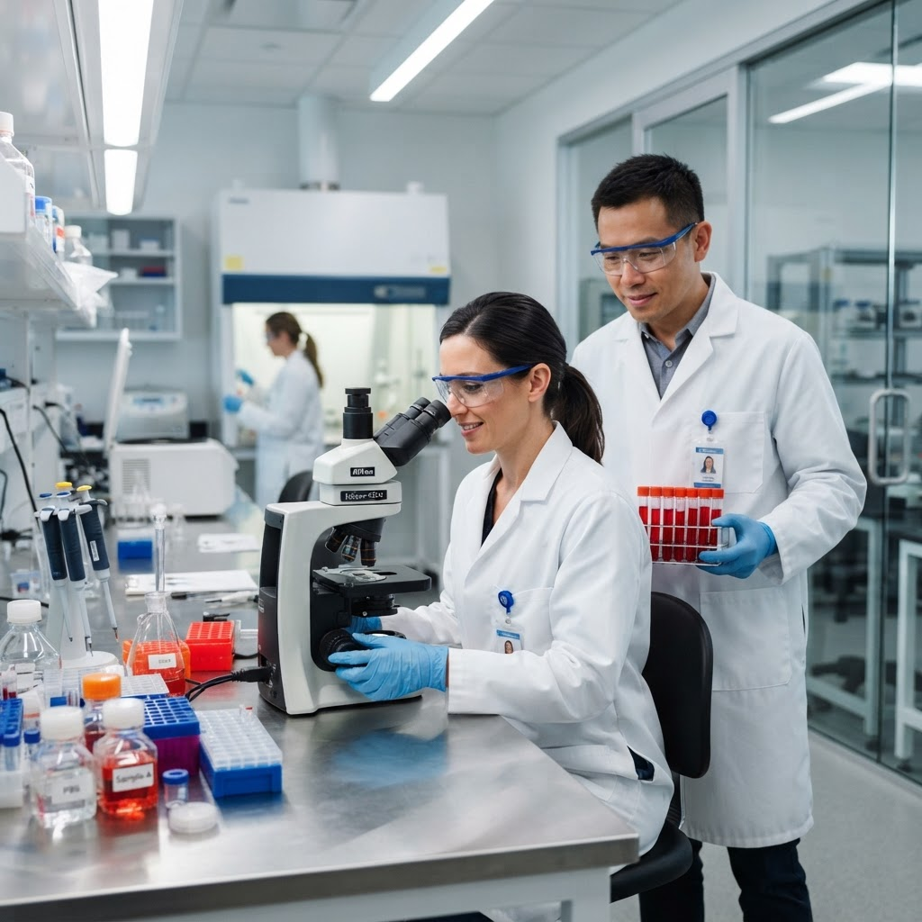
March 18, 2026
Advances In Oral Solid Dosage Manufacturing Manufacturing and Analysis of drug formulations
AdminManufacturing
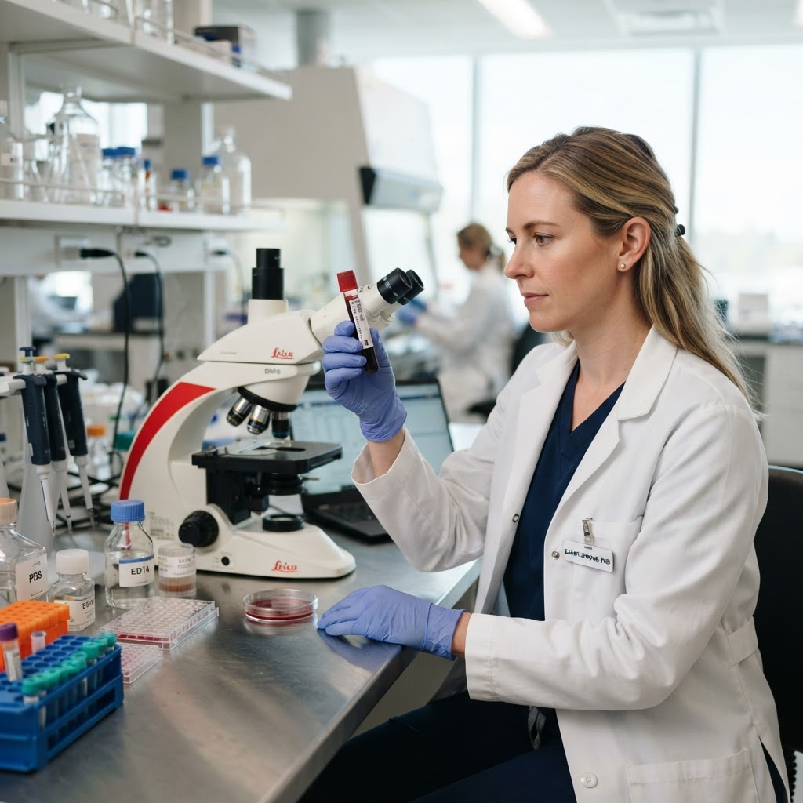
March 18, 2026
Standardizing Sample Handling In Clinical Labs Remove
AdminLaboratory

March 18, 2026
AI-Powered Drug Discovery In Modern Research
AdminBiology
View All Posts
FAQ
FrequentlyAsked Questions
Everything you need to know about placing orders and working with Samay Pharma.
What is the minimum order quantity (MOQ)?
Our MOQ varies by product category. For most medicines, the minimum order is 1 carton (typically 100-500 units). Please contact our sales team for specific product MOQs.
Are all products WHO-GMP certified?Remove this question
What are your payment terms?
Do you handle temperature-sensitive products? Remove -20 degree from the answer
How can I track my order?
Do you supply to international markets?

Start Your Partnership Today
ReadytoOutsourceQualityPharmaProducts?
Partner with Samay Pharma for third-party manufacturing — quality medicines at a fair price, from our Kala Amb plant.
Get a Free Quote
Call Us Now
GMP-GLP · ISO 9001:2015 · FSSAI
Contact Us
Let's Start a Conversation
Our pharmaceutical experts are ready to help you with the right medicines, competitive pricing, and manufacturing partnerships.
Call Us
+91 98166 67007
Mon – Sat, 9 am – 6 pm IST
Email Us
support@samaypharmaindia.com
Reply within 2 business hours
Address
Plot no. 34/35, Industrial Area Road
Trilokpur Road, Kala Amb, Himachal Pradesh 173030 Remove
India
Business Hours
Mon – Fri: 9:00 am – 6:00 pm
Sat: 9:00 am – 2:00 pm
Sunday Closed
Quick Inquiry
Send Us a Message
Responds in 2h

Full Name *
Email Address *
Company / Hospital
Phone Number
Inquiry Details *
Send Inquiry
SSL Secured
No Spam
GDPR Safe


India's trusted pharmaceutical manufacturing company. Quality medicines since 1999.
+91 98166 67007support@samaypharmaindia.com
Plot no. 34/35, Industrial Area Road, Trilokpur Road, Kala Amb, Himachal Pradesh 173030
Company
- About Us
- Our Team
- Certifications
- Infrastructure
- Careers
Products
- Capsules
- Tablets
- Oral Liquids
- Ointments
Services
- Bulk Procurement
- Cold Chain Logistics
- Export Services
- Regulatory Support
- Custom Packaging
Resources
- Blog
- FAQ
- Product Catalog
- Contact
- Privacy Policy
Subscribe to Product Updates
Get notified about new products, offers, and regulatory updates.

Subscribe

© 2026 Samay Pharma India Pvt. Ltd. All rights reserved.

